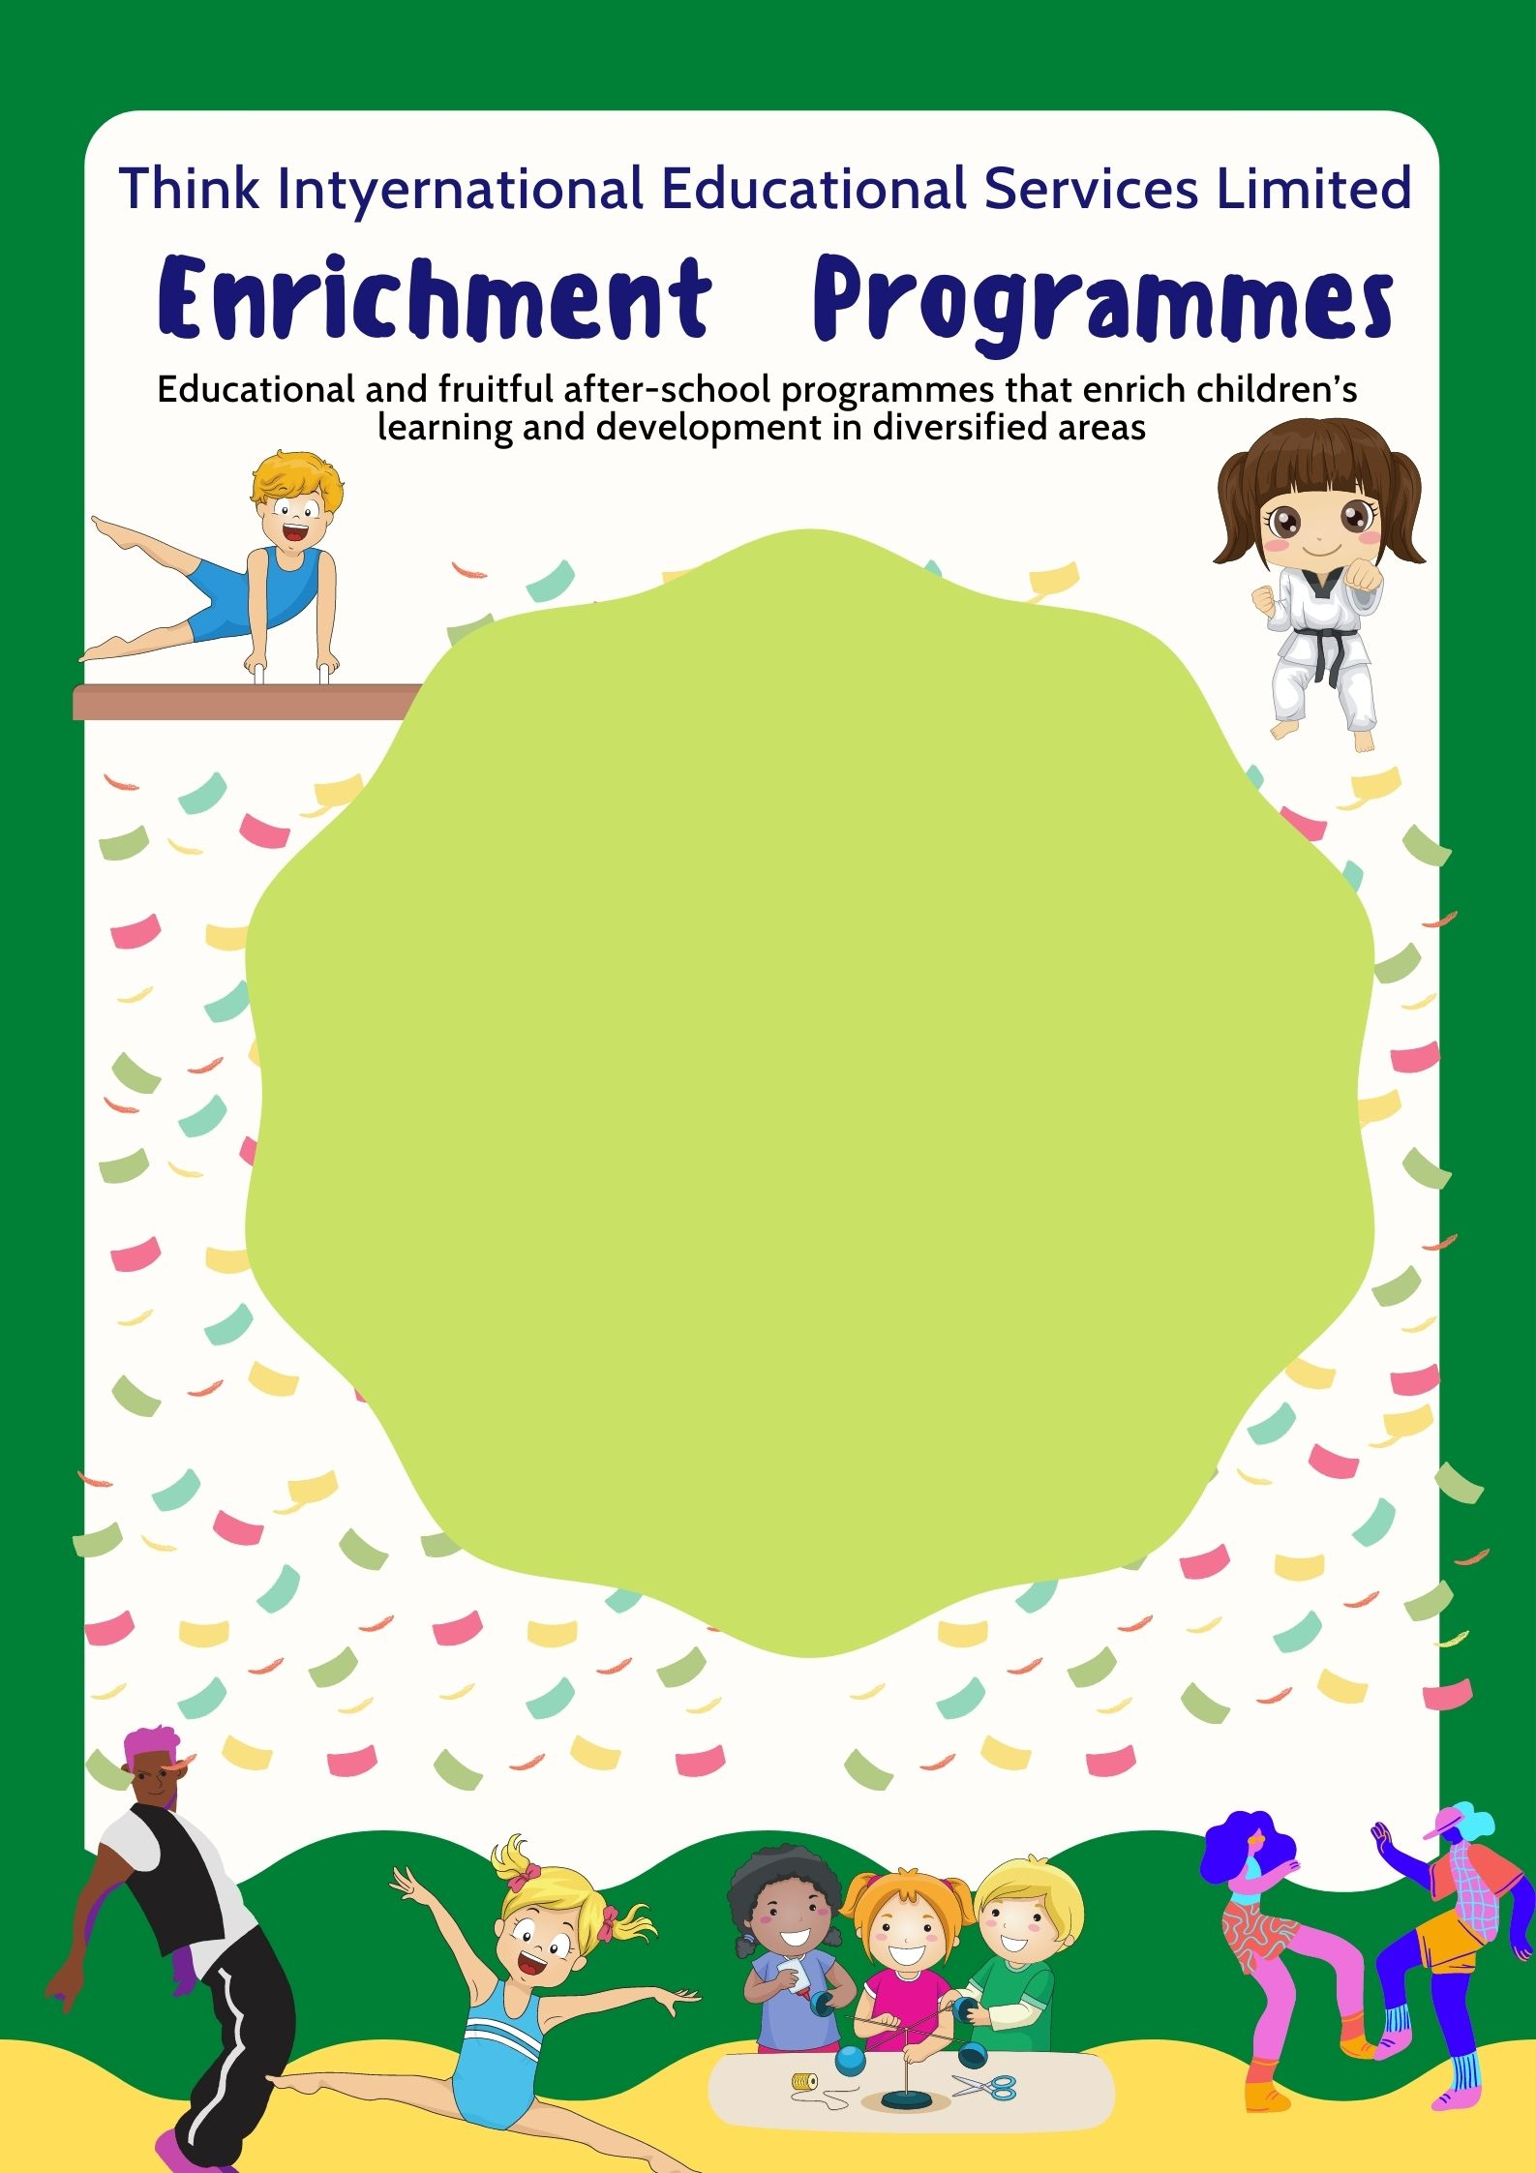
Please submit the enrolment form before 02/09/2021
請於02/09/2021前交回報名表
Sept to Oct 2021
Inquiry 查詢電話 : 2157-2111
Fax 傳真︰2157-2000
Address 地址 : Shop G26 V Walk G/F.,
28 Sham Mong Road, Shamshuipo, Kln.
九龍深水埗深旺道28號V Walk 地下G-26室
(南昌西鐵站)
Website 網址 : www.think.edu.hk

Fun with Taekwondo

Code | Age | Day | Time | Fee  (2 months) | Class Dates  (8 lessons)
T1 | 3 to 6  (LN -UK) | Monday | 4:15pm-5:15pm | $1600- | Sept 6, 13, 20, 27  Oct 4, 11, 18, 25
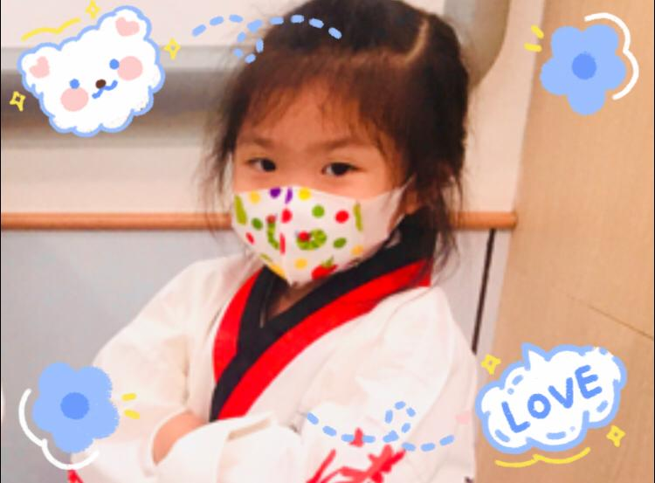
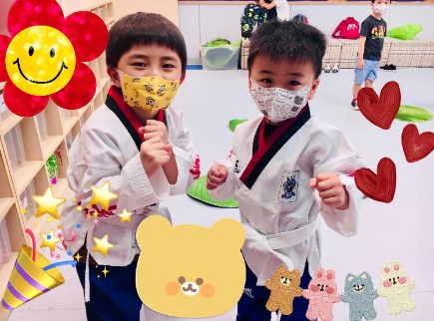
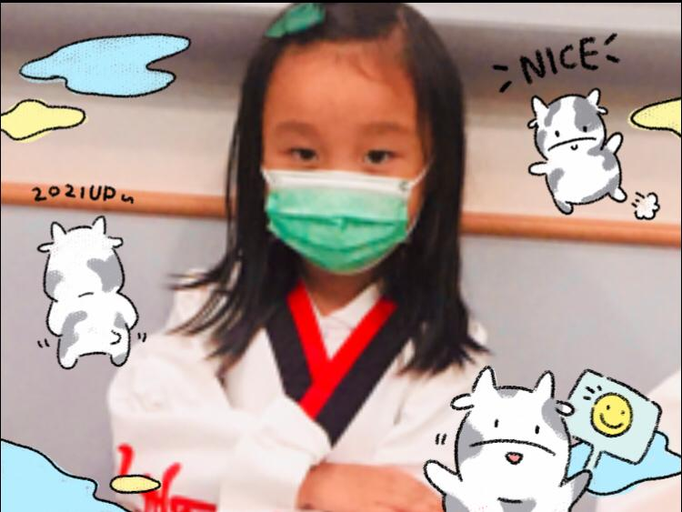
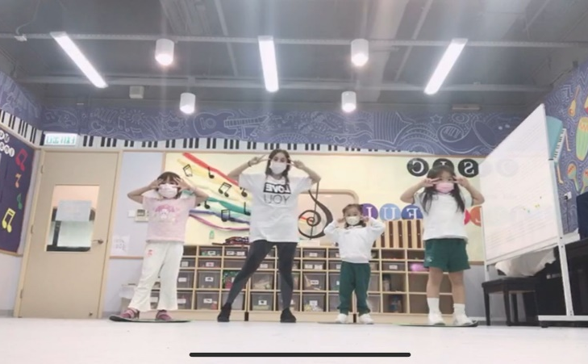
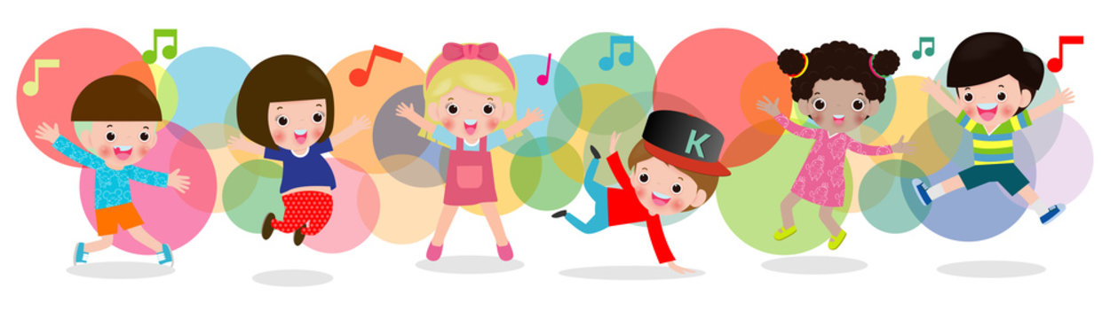
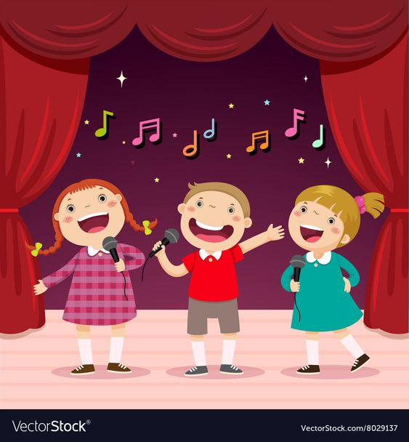
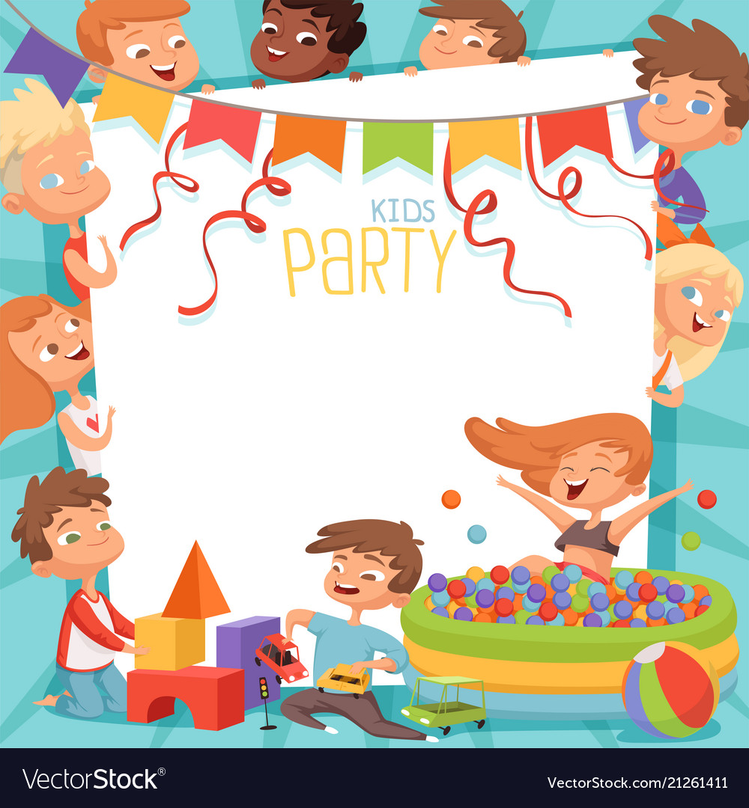
This Taekwondo programme aims at enriching students with the spirit of taekwondo and to providing a strong foundation for character building. Students are encouraged to progress through the belt system: white, yellow, green, blue, red and black so that they can mature physically and spiritually. Examination will be organized for students around once per year (subject to students’ progress). This programme is well-structured and well-recognized, so that students can bridge up to other Taekwondo classes in future even they graduate from our Kindergarten.

year (subject to students’ progress). This programme is well-structured and well-recognized, so that students can bridge up to other Taekwondo classes in future even they graduate from our Kindergarten.
** Remarks: Students will need to purchase the Taekwondo uniform ($350 for
whole set). Parents’ notice will be distributed later for parents to order with instructor directly.

Language of Instruction: Cantonese supplemented with English
Language of Instruction: Cantonese supplemented with English
Fun with Hip Hop

Hip Hop dance is corporates old and new dance moves and styles like break dancing, popping, crumping and even traditional jazz moves. A large part of hip hop dance is creativity and improvisation and just letting the music move you. This is a great way to encourage creativity and expression through dance classes for children.
Code | Age | Day | Time | Fee  (2 months) | Class Dates  ( 7 lessons)
H1 | 2 to 6  (LN - UK) | Tuesday | 4:15pm-5:00pm | $1400- | Sept 7, 14, 28,  Oct 5, 12, 19, 26  (No class on  Sept 21)

Fun with Science
Exploration
Language of Instruction: Cantonese
Joint programme with Hands On Science Outreach (HOSO)
- Our selected science courses are aimed to broaden horizons and stimulate “science in your life” awareness of the students. Students will learn through the fun of active involvement in experiments, games and projects. There are hands-on materials every class that go home with the children.
Code | Age | Day | Time | Fee  (2 months) | Class Dates  (7 lessons)
S1 | 3 to 6  (UN -UK) | Wednesday | 4:15pm-5:15pm | $1260- | Sept 8, 15, 29  Oct 6, 13, 20, 27
- This is a progressive programme for whole school year. Children who completes the whole year programme can request HOSO to apply for assessment and certification of learning with the British Science Association for the “BA Young People’s Programme Certificate” (Bronze/Silver/Gold Certificates).
- Themes：
🔸Sept – Oct
Can you feel the friction? Build a maze through which things can roll. How do different cylinders and spheres travel down the ramp? Construct your own mode wheels and axles. Experimenting with pulleys and windlasses. Make a windmill and see how it twirls through the air. Create your own spinning toy.

Enrolment Form
Think International Educational Services Limited

Name of Child : | (Eng) |  | (Chi)
Birthday (D/M/Y): |  |  | Sex:
Parent’s Tel. No.: | (Mobile) |  | (Home)
Home Address:
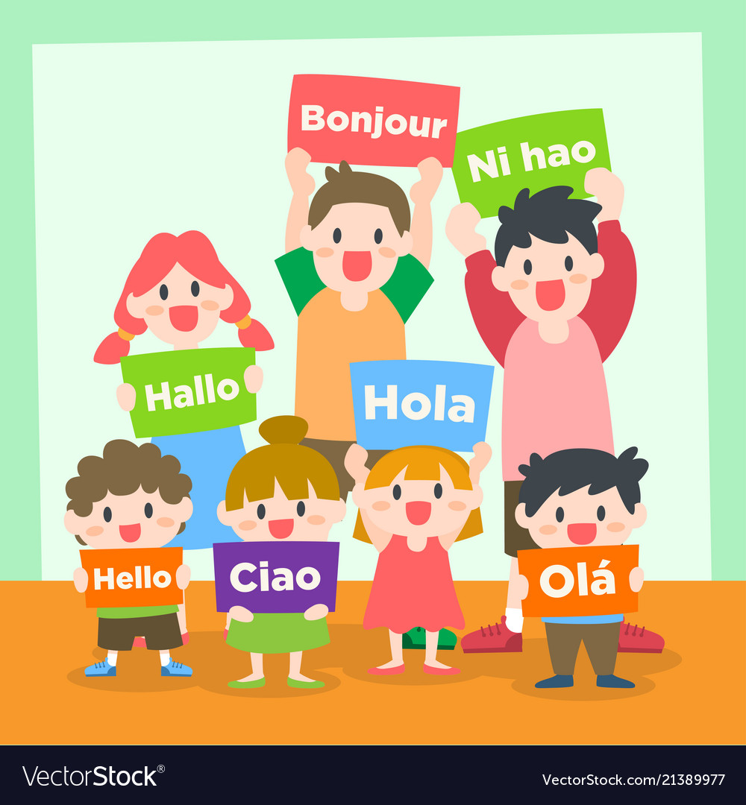

Please submit (a) completed Enrolment Form &
(b) crossed cheque payable to
“Think International Kindergarten O/B Think International Educational Services Ltd.”
to our office in person. We will issue official receipt once the enrolment is confirmed.

Enrichment Programmes
Enrolment Form
Crossed cheque payable to
“Think International Kindergarten O/B Think International Educational Services Ltd.”
Cheque Number : ___________________
Amount : $__________________
Programmes to enroll
 | Fun with Taekwondo (Monday) |  |  |  | T1 $1600-
 |  | Fun with Hip Hop Dance (Tuesday) |  |  | H1 $1400-
 |  | Fun with Science Exploration(Wednesday) |  |  | S1 $1260-
 |  |  | Fun with Jazz Funk (Thursday) |  | J1 $1400-
 |  |  | Fun with Gymnastics (Friday) | G1 $1260- | G2 $1260- |  | G3 $1400-
 |  |  | Fun with Putonghua (Thursday) | PTH1$1610- |  | PTH2 $1610-
 |  |  | (Is your child allergic to any materials? No / Yes ____________________________)
Enrolment and Programme Regulations
- All fees paid are non-refundable.
- Children not being able to attend class will not receive refund or make up class.
- For Typhoon No. 3 and Red Rainstorms or higher signal are hoisted, the lesson will be cancelled and a make up class will be held later.
If the Red/Black Rainstorm signal is in effect while the kindergarten is in session,
children will continue their session at school.
- Children having fever or not feeling well are encouraged to stay home to take rest.

After School Fun
Code | Age | Day | Time | Fee  (2 months) | Class Dates  (7 lessons)
PTH 2 | 4 to 6  LK- UK | Thursday | 4:15 pm –  5:15 pm | $1610- | Sept 9, 16, 23, 30  Oct 7, 21, 28
Code | Age | Day | Time | Fee  (2 months) | Class Dates  (7 lessons)
PTH 1 | 2 to 4  LN-UN | Thursday | 12:00 noon –  1:00 pm | $1610- | Sept 9, 16, 23, 30  Oct 7, 21, 28
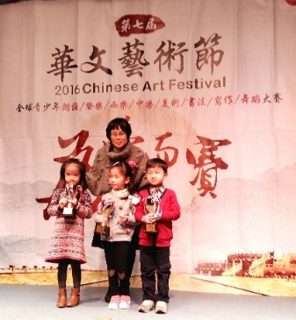
普通話水平测試班
對象：3－6歲 (UN/UK)
內容：教授GAPSK,BNCL,KPCC水平测試內容。
證書：已報名測試的幼兒須連續出席兩期。專為小一面試做準備的幼兒而設。

普通朗誦班
對象：2－6歲（LN-UK）
內容：朗誦兒歌、唐詩、繞口令、 講故事、散文詩、角色扮演、 少年兒童節目主持人等。
證書：連續出席兩期的幼兒，可參加全港各機構朗誦比賽。專為小一面試做準備的幼兒而設。

Language of Instruction: Putonghua

Fun with Putonghua
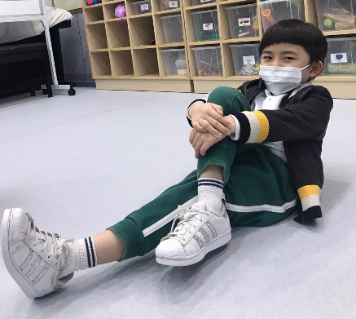
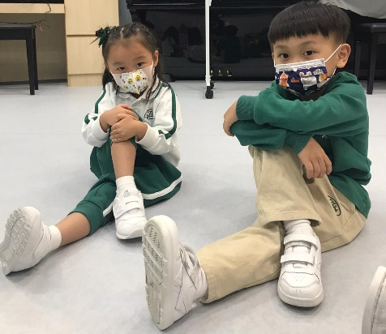
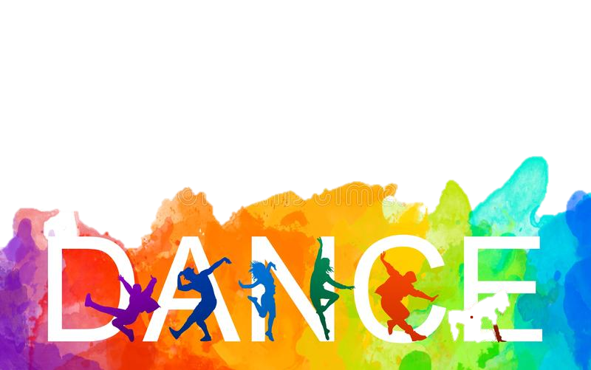
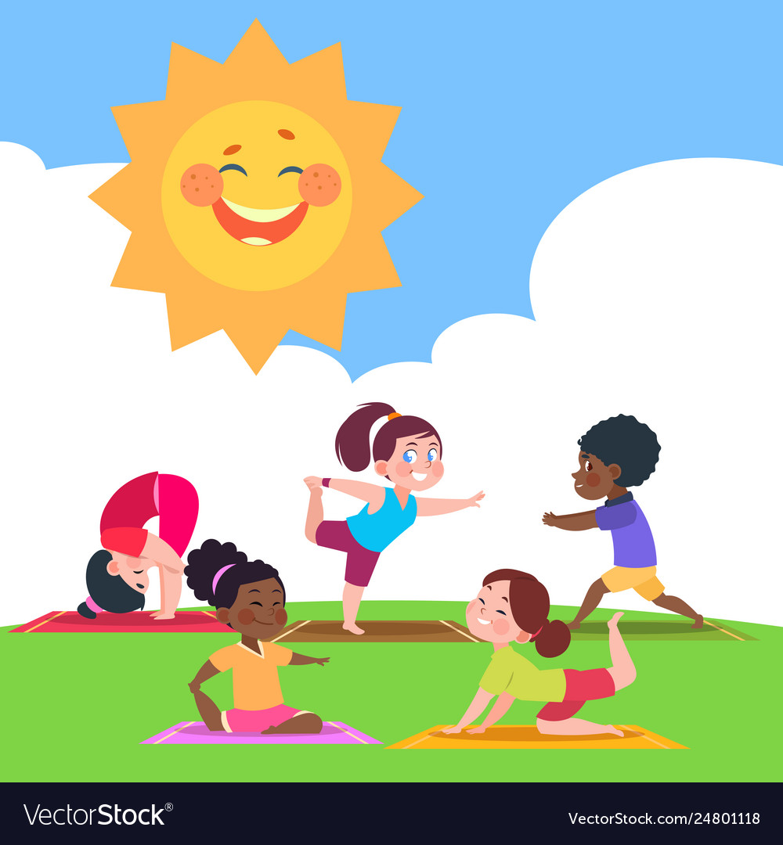
Jazz-funk dance, a super-set of the Jazz form of dancing is influenced by the Hip Hop dance style. From ballet-modern-hip hop-to lyrical, jazz-funk incorporates little bits and pieces of other dance genres and wraps into a funky style that is both fun and expressive! Jazz Funk is a dance style of body and mind training that offers children a chance to develop their body coordination ability and self-confidence.
Code | Age | Day | Time | Fee  (2 months) | Class Dates  ( 7 lessons)
J1 | 2 to 6  (LN - UK) | Thursday | 4:15pm to 5pm | $1400- | Sept 9, 16, 23, 30  Oct 7, 21, 28

Fun with Jazz Funk
Language of Instruction: Cantonese
Language of Instruction: Cantonese supplemented with English
Fun with Gymnastics
Code | Level | Age | Day | Time | Fee  (2 months) | Class Dates  (7 lessons)
G1 | Beginners | Up to 3 | Friday | 4:15pm to 5pm | $1260- | Sept 10, 17, 24  Oct 8, 15, 22, 29
G2 | Level 1 | 3 to 5 | Friday | 4:15pm to 5pm | $1260-
G3 | Level 2 | 5 to 12 | Friday | 4:15pm to 5:15pm | $1400-
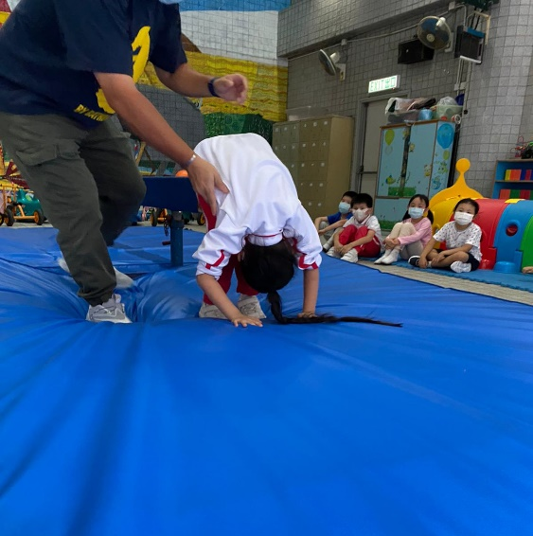
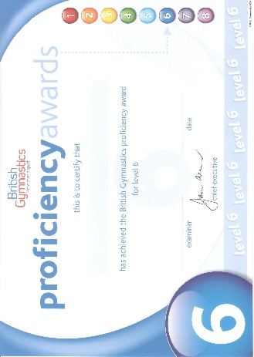
This gymnastic program, which is offered throughout the year, helps to tone up the muscles of the children and make them healthier, fitter and happier through a series of planned physical activities. Gymnastics activities can strengthen children’s motor skills, hand-eye coordination, physical ability as well as foster their self-confidence and self-discipline.

